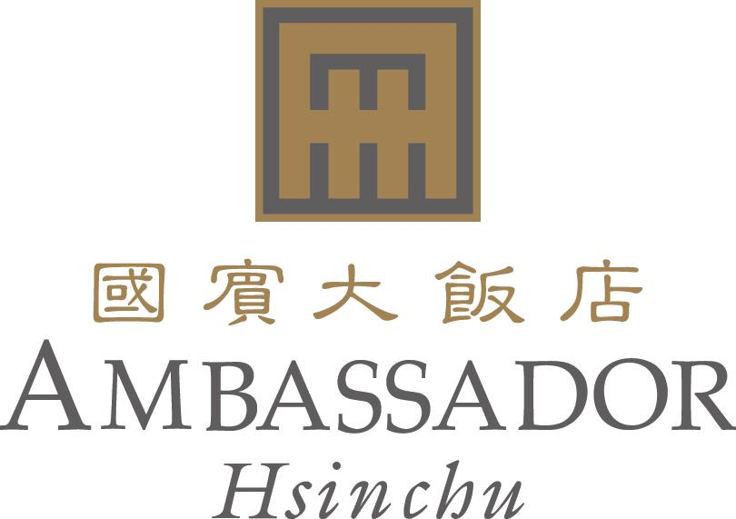

RESERVATION FORM
e-Manufacturing & Design Collaboration Symposium 2014 (Sept12th, 2014)
Reservation deadline: 2014 /08 /15
No.188 Sec 2, Chung-Hua Road, Hsinchu, Taiwan 新竹市中華路二段188號
E-mail：rsvn@ambassador-hsinchu.com.tw & reserv@ambassador-hsinchu.com.tw
Web Site:www.ambassadorhotel.com.tw
Tel：886-3-515-1111 Fax : 886-3-515-1216
Please kindly contact us if you have not received any feedback in 24 hours.
Confirmation Number

Guest Name
Date | Check In： | Check Out：
Telephone
Fax
E-mail
Number of rooms required | □ Single with 1 BF | □ Twin/Double Rate
Room Rate | NT$4,300+10%+5% | NT$4,750+10%+5%
Special room requirement | □ Non-smoking □ Other
Note | The price above is including daily breakfast.

TRANSPORTATION
- Airport pick up service from Taoyuan International Airport to Hotel. NT2,000 Net per trip.
Flight Number： Arrival Time：

CREDIT CARD
Guarantee：Please advise your credit card detail at your earliest convenient to guarantee your room reservation.
□ Visa □ Master Card □ American Express □ Diners
Credit Card No： Expire Date：
Signature： Date：

Important Notice
Cancellation Policy：Non-guarantee booking will be released at 18:00 and guaranteed booking will be charged one night room rate if not cancelled by 18:00 on the date of arrival.

HOTEL INFORMATION

Ambassador Hotel Hsinchu
Website: http://www.ambassadorhotel.com.tw/HC/ambassador_hsinchu.htm?LC=EN
Tel：886-3-515-1111
Fax : 886-3-515-1216
Address: No.188 Sec 2, Chung-Hua Road, Hsinchu, Taiwan 新竹市中華路二段188號
Check-in: 3pm Check-out: 12pm

Hotel Lobby
There are two lobbies in the hotel. The first floor lobby is the Service Center lobby. For checking in, please go to the 12th Floor lobby.

Hotel Free Shuttle Service
- The Hsinchu Science Park Shuttle
Free shuttles to Hsinchu Science park, GongDao 5th Road, Tai Yuen Hi-Tech Industrial Park, and Hu Kou Industrial Park etc from Monday to Friday morning. (Departure time 07:30am, 8:00am, 8:30am; more info please call extension number 3541 to reach the hotel guest services)
- The Ambassador Hotel Taipei Shuttle
Free shuttles to the Ambassador Hotel Taipei on Saturday and Sunday. (Departure at 10:00am; return departure time 9:00pm)

