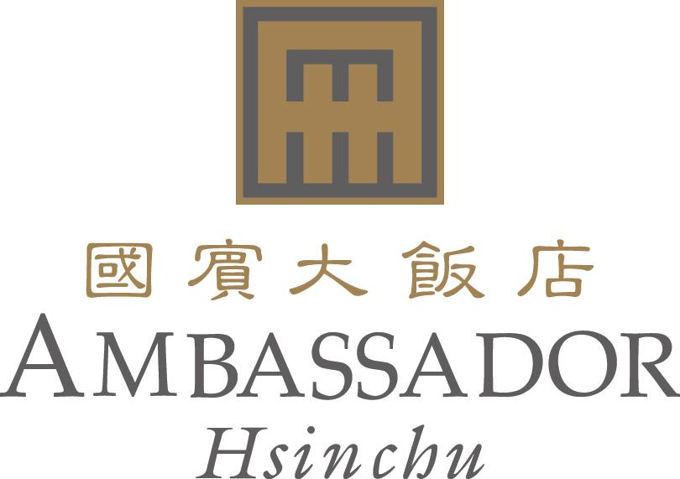

RESERVATION FORM
e-Manufacturing & Design Collaboration 2012
Reservation deadline : 2012/8/10
No.188 Sec 2, Chung-Hua Road, Hsinchu, Taiwan 新竹市中華路二段188號
E-mail：rsvn@ambassador-hsinchu.com.tw & reserv@ambassador-hsinchu.com.tw
Web Site:www.ambassadorhotel.com.tw
Tel：886-3-515-1111 Fax : 886-3-515-1216
Please kindly contact us if you have not received any feedback in 24 hours.
Confirmation Number

Guest Name
Date | Check In： | Check Out：
Telephone
Fax
E-mail
Number of rooms required | □ Single with 1 BF | □ Twin/Double Rate
Room Rate | NT$4,450+10% | NT$4,900+10%
Special room requirement | □ Non-smoking □ Other
Note | The price above is including daily breakfast and 5% tax.

TRANSPORTATION
- Airport pick up service from Taoyuan International Airport to Hotel. NT2000 Net per trip.
Flight Number： Arrival Time：

CREDIT CARD
Guarantee：Please advise your credit card detail at your earliest convenient to guarantee your room reservation.
□ Visa □ Master Card □ American Express □ Diners
Credit Card No： Expire Date：
Signature： Date：

Important Notice
Cancellation Policy：Non-guarantee booking will be released at 18:00 and guaranteed booking will be charged one night room rate if not cancelled by 18:00 on the date of arrival.

